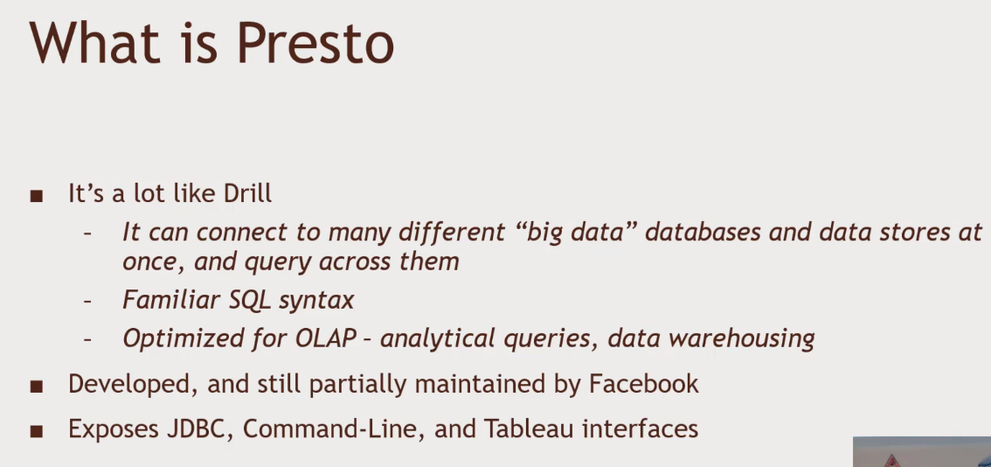Presto – for Data Analytics No need to be super quick.

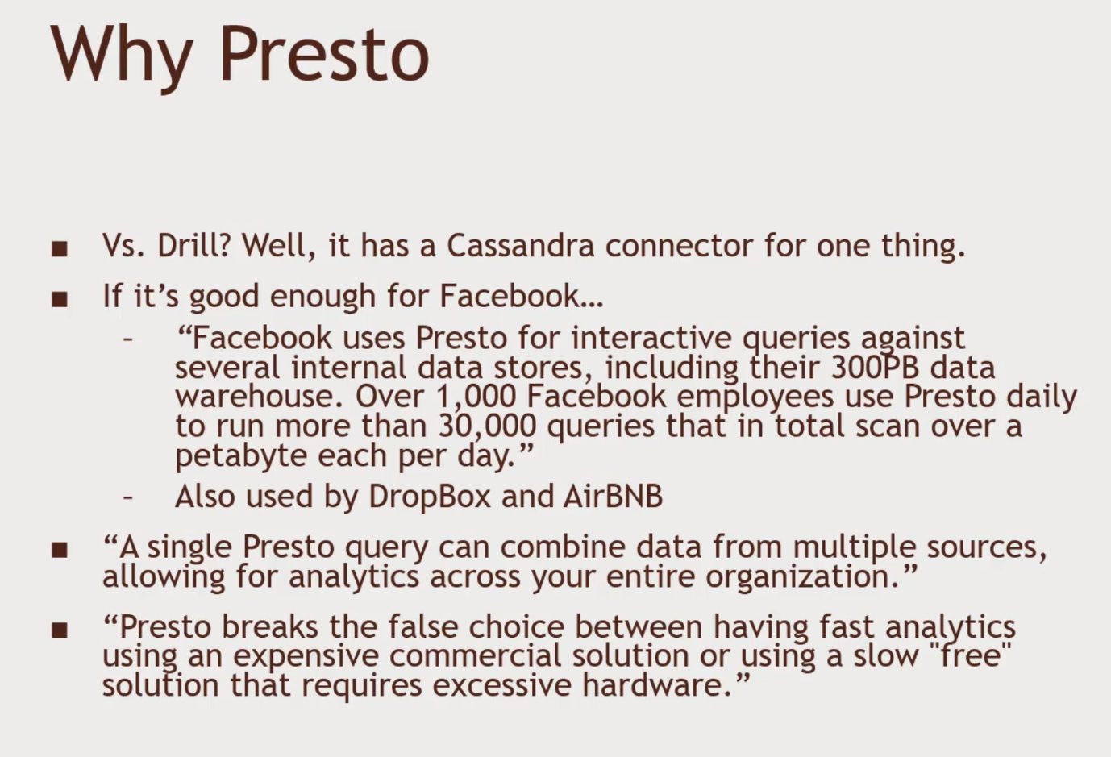Data Lake- a big pool of flat data, stored in distributed data systems

Presto can connect to

* Cassandra
* Hive
* MongoDB
* MySQL
* Local Files
* Kafka – Real time data Streaming data application. Data coming in real time
* PostgreSQL – relational data pace
* Redis, Accumulo